ARCON SCM Training Document

**A**RCONSCM:

**SCM AUDIT**

SCM Gateway

Server Manager

Server Manager

UI - It contains all UI elements

WEB API - each and every folder is a web API

SCM Audit - It contains application service folders.

Audit

Corewebapi

Dashboard

Emailservices

Scheduler

Syncwithpam

SCM Gateway – It can be installed with the application server or on a separate machine. It acts as interface between application server and the target server.

Appwebapi

Connection

Corewebapi

Remedetionconsole

Remedetionservices

Reporting

All the three folders have different appsettings.json. All the appsettings are same in all the folders in respective folders (Audit, gateway, server manager).

If any changes are made to the appsettings of any folder, save the file. After saving the file the specific services should be restarted.

Except for UI, the browser should be closed altogether and then started again and then login for the changes to be reflected.

How to decrypt any encrypted string?

ARCONSCM > SCMEncDectool > ARCONSCMEncDec.exe

**Server Manager**

UI app settings (Default)

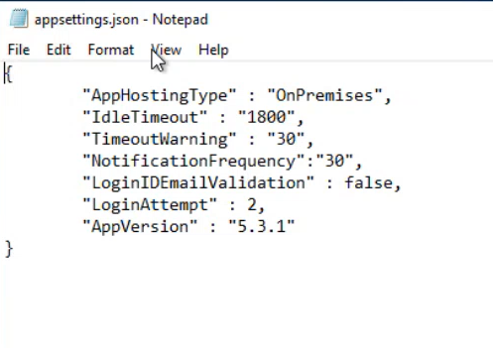

* App hosting type:

- If it is “on premises” admin will create the users.

- If it is “on cloud” user will get a registration link on the login screen.

* Idle Timeout: If your system is Idle for 1800 sec it will log you out.
* Timeout warning: Before logging out it will give you a warning.
* Notifications frequency: It will check after every 30 sec if there is a notification on dashboard.
* Login ID email validation: It will validate if the username entered is an email address or not.
* Login Attempt: Number of logins attempt after which user id will be locked.

**Web Api**

Appsettings (Default)

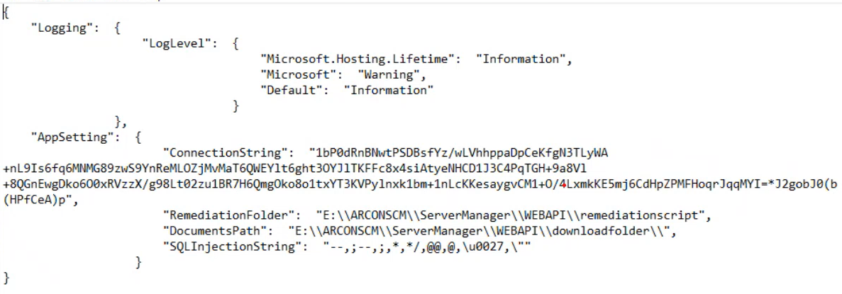

**Connection String**: It contains information about connection to the database.

**Remediation Folder**: Path of the remediation script

**Documents Path**: Path of the downloads folder.

To update any detail in the connection string such as credentials or database info, please follow the below steps:

1. Open appsettings.json and copy the connection string.
2. Paste it into EncDectool (Enc Text) and click **Decrypt**.
3. Copy the plain text and edit it in Notepad as needed.
4. Paste the updated text back into EncDectool (Plain Text) and click **Encrypt**.

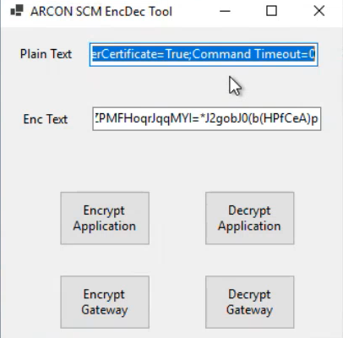

1. Copy the encrypted string and replace the connection string in appsettings.json.
2. Save the file.
3. Paste the updated appsettings.json into all required folders **except** Download and Remediation Script.
4. Open **IIS (Internet Information Services)**.
5. Under **Connections**, select **APPSCMVR1**.
6. In the **Actions** pane on the right, click **Restart.**

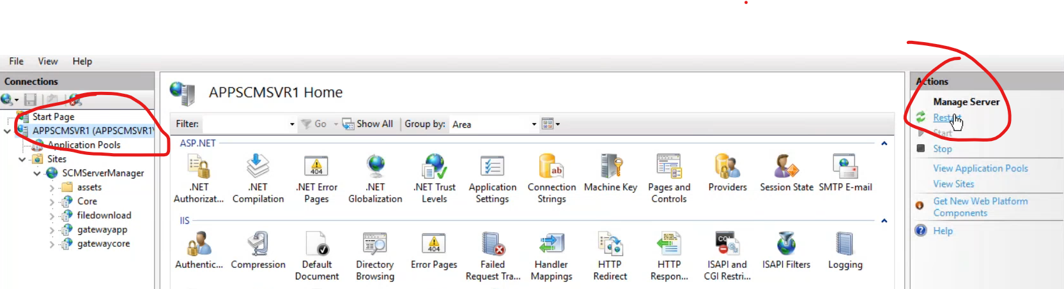

To change the download path to a different drive/folder or shared drive in case of HA , Active- Active configuration, follow the below steps.

1. Navigate to the desired folder/drive and copy the path from the address bar.

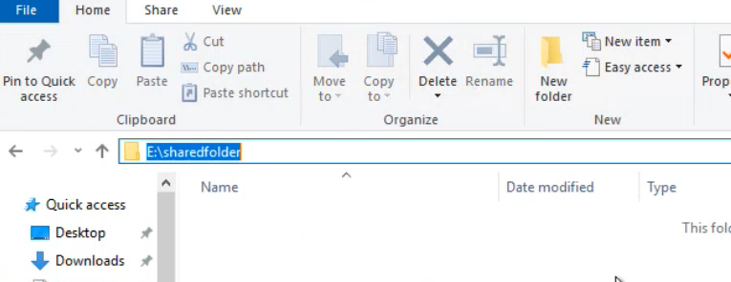

1. Open appsettings.json and paste the path in the **"Documents Path"** field, replacing each \ with \\ (e.g., C:\New folder → C:\\New folder\\).
2. Save the file and copy it into all folders under **Server Manager**.
3. Open **IIS**, select **Server Manager** on the left.

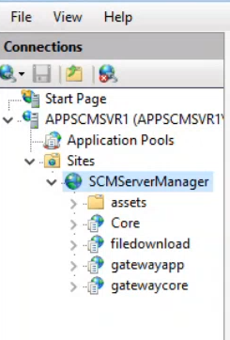

1. In the **Actions** pane, click **View Application**

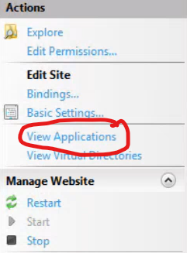

1. Select **/file download >** Click **Basic Settings.**



1. Update the **Physical Path** to the new shared drive/folder path, and click **OK**.

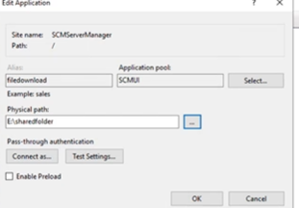

As there are 2 application servers for active-active configuration follow the above steps in the second application server as well.

**SCM AUDIT**

App settings (Default)

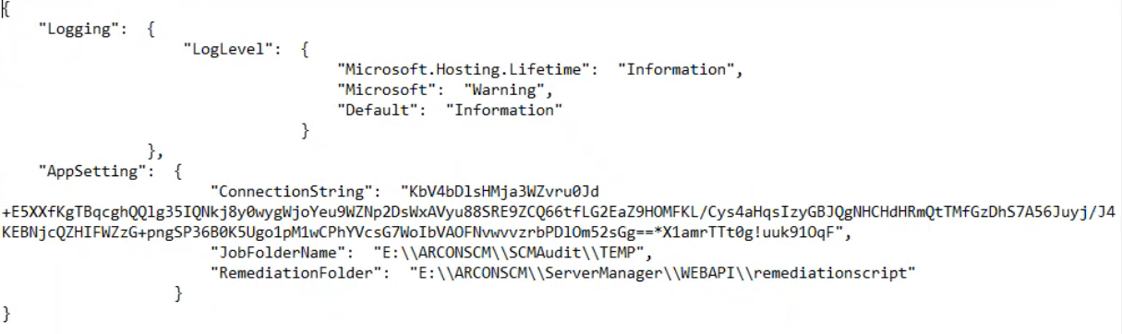

Connection String: It contains information about connection to the database (credentials, data base info, etc.).

Job Folder Name: The Job Folder points to the **TEMP** directory located within each SCM audit and Gateway folder. It stores connection details, output logs, and remediation data generated during audits. All services use this folder to save temporary logs.

Remediation folder: Path of the remediation script

To change the download path to a different drive/folder or shared drive, follow the below steps.

1. Navigate to the desired folder/drive and copy the path from the address bar.
2. Open appsettings.json and paste the path in the **"JobFoldername"** field, replacing each “\” with “\\” (e.g., C:\New folder → C:\\New folder\\).
3. Save the file and copy it into all folders under the **SCM Audit** directory, including **Audit > Plugin**, excluding the **TEMP** folder.
4. Open **Services** (services.msc).
5. Restart the services corresponding to the folder names under the **SCM Audit** folder.

After an audit gets completed, there are two ways you can download a report.

* Live status (template method)
* Report management (own set of libraries)

Templates:

ARCONSCM > SERVER MANAGER > WEBAPI > DOWNLOAD FOLDER > TEMPLATE

1. **Template Location**

* Templates are stored in: Server Manager > Web API > Download > Template folder
* Templates are in .XLS format (not .XLSX)
* Each template is specific to different asset types (e.g., AIX server, Apache Tomcat, Cisco router)

1. **Template Structure**

* Contains multiple tables and graphs
* Graphs are generated based on table data
* Includes pre-configured formulas for calculations

1. **Template Customization Options**

* Modify column positions
* Add/remove columns
* Adjust formulas
* Change section titles
* Customize compliance and criticality tracking

1. **Report Download Methods**

* Two ways to download reports:

a. Via Live Status

b. Via Reports Management

1. **Important Customization Tips**

* Always save modified templates in .XLS format
* Replace original template with customized version
* Verify report reflects template changes after download

1. **Recommended Workflow**

* Open template
* Make desired modifications
* Save in .XLS format
* Replace original template
* Download report to confirm changes

1. **Potential Customization Examples**

* Remove unnecessary columns (e.g., CPU ID)
* Adjust compliance and criticality tracking
* Modify section titles and layout

Remember: Careful formula editing is crucial to maintain report accuracy.

**Gateway**

**Appsettings.json**

It interacts with the application server and the target server.

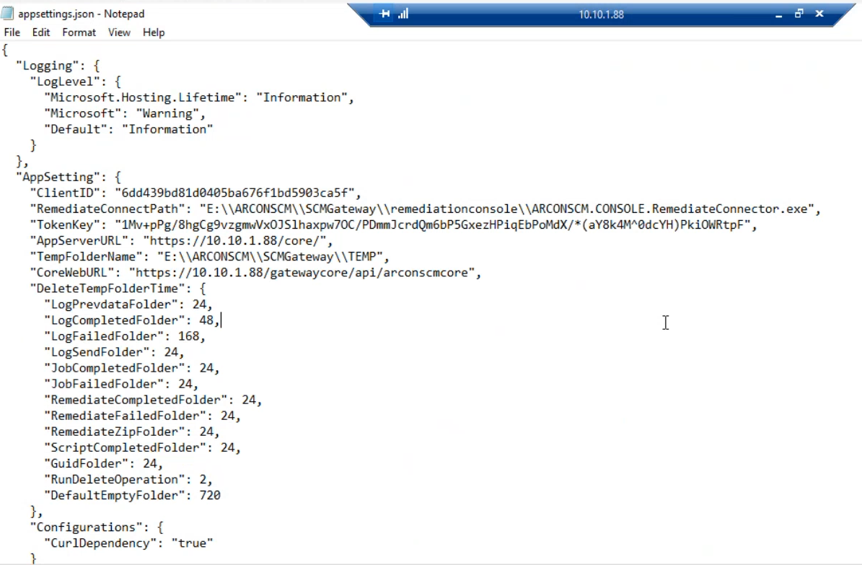

Remediationconnectpath: Normally set by OCI. Path of the remediation script.

TempfolderName: In case of shared folder paste the path of the shared folder in this section.

If you want to completely move the gateway folder to a different folder then you have to change the location in both tempfoldername and Remediationconnectpath

Appserverurl: this consists of the connectivity information to connect the gateway to the application server.